Analyzing a Desert Food Web

- A student doing research collects the following information about feeding relationships in a desert ecosystem.
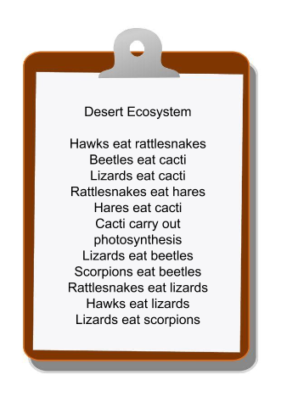
  - Use these notes to construct a food web of this ecosystem on a separate sheet of paper. Be sure to indicate the direction of energy flow on your food web.

  - Draw a single food chain that includes 4 organisms from the desert ecosystem.

  - In your food web, identify one organism that is an example of each of the following trophic levels or ecological roles:

producer carnivore
primary consumer herbivore
secondary consumer omnivore
decomposer

  - Describe the most likely short-term effect of each of the scenarios.

  - The hawk population increases.

  - The cactus population decreases.

  - The hare population decreases.

